Untitled

the don

Monday, February 02, 2015

Loading ish

library(ggplot2)  
library(RColorBrewer)  
library(utils)  
GCN2 <- read.csv("~/GCN2.csv")

console plot 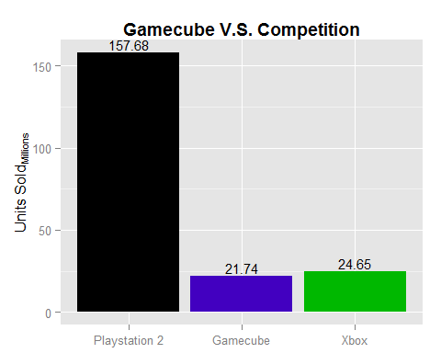

regions plot 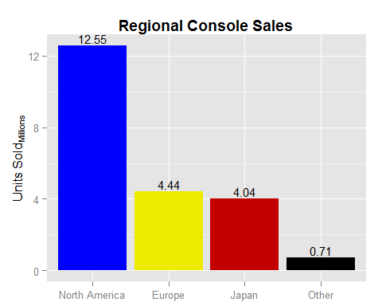

years plot 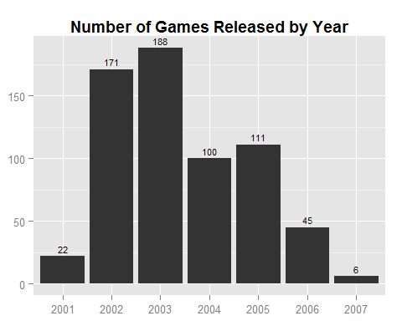

genre table

summary(GCN2$Genre)

## ActionAdventure Collection Fighting Miscellaneous   
## 136 10 43 7   
## Music Party Platformer Puzzle   
## 6 15 80 15   
## Racing RolePlaying Shooter Simulation   
## 75 32 61 11   
## Sports Strategy   
## 137 15